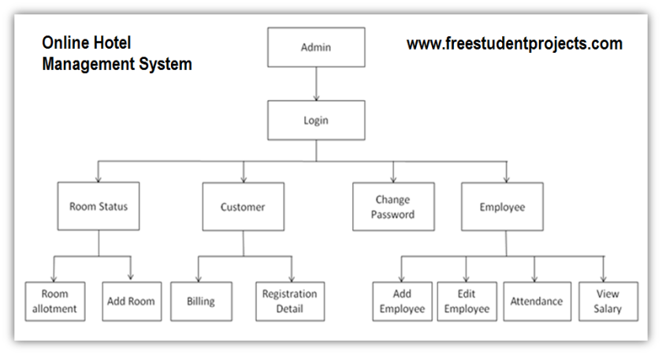

User stories:

**Room allotment**: As a user, I want to be able to request a room allotment through a online platform so that I can easily select my preferred accommodation and also have a place to stay.

As a user, I want to know the details about the room, so that it is easy to find the better room.

**Add room:** As a user**,** I want to be able to add a new room to my profile, so that I can organize and categorize my spaces effectively.

As a hotel manager, I want to specify the details of the new room, including room type, capacity, and pricing, so that guests have clear information when booking.

As a guest, I want to see the newly added room listed among the available options when browsing for accommodations, so that I can make an informed booking decision.

**Billing:** As a guest, I want to be able to view a detailed breakdown of my charges, including room rate, additional services (such as meals or spa treatments), taxes, and any discounts applied, so that I can review and understand my final bill before making payment.

As a hotel manager, I want to be notified of any irregularities in billing, such as incorrect charges or missing payments, so that I can promptly investigate and resolve any issues to ensure accurate financial records.

As a hotel staff member, I want to be able to generate invoices automatically at the end of a guest's stay, including all relevant charges and payment details, so that guests can efficiently settle their bills during checkout.

**Registration details:**

As a user, I want to register online by providing basic personal information such as name, contact details, email, and password.

As a user, I will receive a confirmation email once I have registered for the application.

As a user, I can log into the application by entering by entering my email and password.

**Add Employee:**

As a manager, I want to add a new employee to the online management system so that they can access company resources and be included in the organizational structure.

As a human resources administrator, I want to be able to add a new employee to the online management system quickly and efficiently to maintain an up-to-date employee roster.

**View salary:**

As an employee, I want to view my salary information in the online management system, so that I can keep track of my earnings and understand how they contribute to my overall compensation package.

As a manager, I want to access salary information for the employees in my department within the online management system so that I can effectively manage payroll and address any compensation-related inquiries.